Scara Robot
~LogBook~
Turn of motion and position lag monitoring
Errors
Exceeds permitted limit = change value positioning lag value to false
Don’t get feedback from the moter =
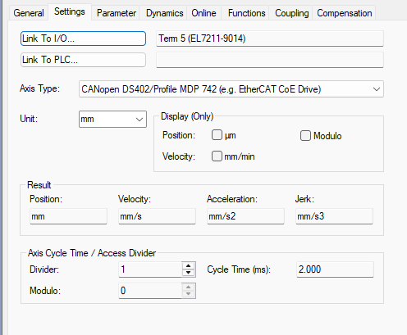
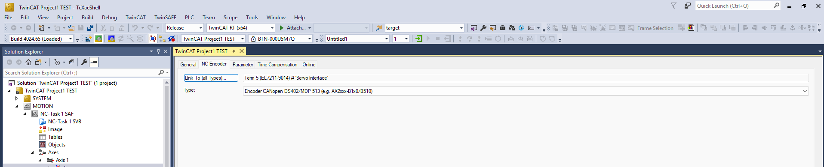
Makes sure this is correct and also have the parameter reference mode in the encoder set to default.

